


  COURAGE ROck participant handbook  2026 | MISSION STATEMENT:  Our mission is to engage and develop the relationship between humans and the therapeutic energy of a horse to strengthen the physical, emotional, and mental well-being of one’s life.

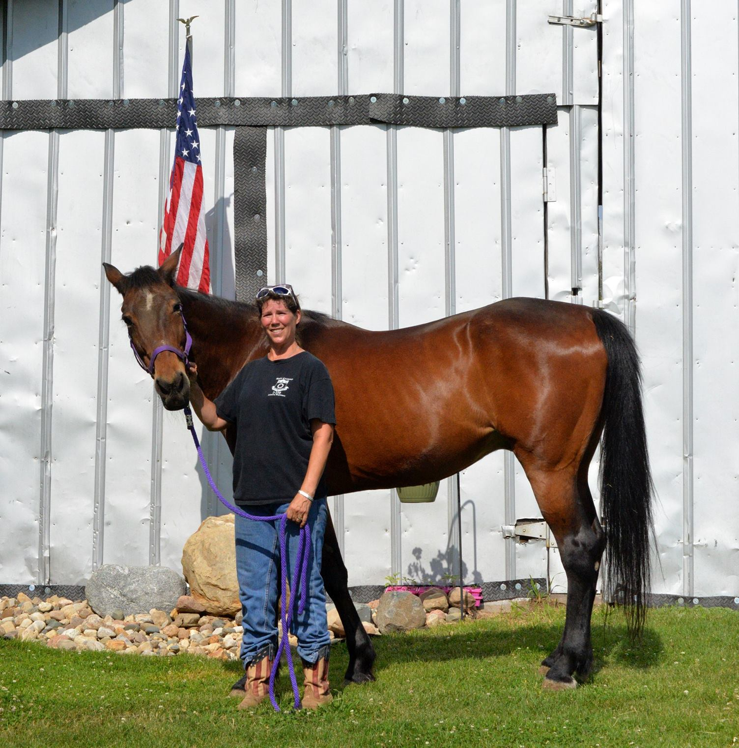

Pictured – Founder Kim Markham and Courage Rock’s Ambassador, Pawnee

Welcome!
Horses touch your thoughts and feelings and together we can help others in need through the therapeutic energy a horse has to offer. In addition to helping have an influence in someone’s life, including a horse, we hope you will make new friends and make lasting memories with your time spent at Courage Rock!
One thing often said at Courage Rock, “Ask often, expect little or nothing, reward generously.” -Chuck Grant.

Thank you for becoming part of our Rock!

Table of Contents
GENERAL INFORMATION .............................................................. 4
History .......................................................................................... 4
PATH Intl. Member........................................................................ 4
Non-Discrimination Policy ............................................................ 4
Benefits of Equine Assisted Services (EAS) ................................ 4-5

OUR PROGRAMS ........................................................................... 5
Therapeutic Riding ........................................................................ 5
Therapeutic Horsemanship ........................................................... 5
Camp Courage ............................................................................... 6
Pony Pals & Pages .......................................................................... 6
Veterans ......................................................................................... 6

POLICIES AND PROCEDURES .......................................................... 6
Fees ................................................................................................ 6
Student Volunteer Ridership ...........................................................6
Making a Payment.........................................................................6-7
Attire ...............................................................................................7
Cell Phones ......................................................................................7
Safety Rules ................................................................................. 7-8
Emergency Procedures ................................................................... 8
Parking and Speed Limit ..................................................................8
Code of Conduct............................................................................8-9

Table of Contents

Grounds for Dismissal ...................................................................... 9
Equine Liability Law ......................................................................... 9

ATTENDANCE ................................................................................... 9
Cancellation Fees ………………………………………………………………………… 9
Participant Illness............................................................................. 9
No Show .........................................................................................10
Late Arrival .................................................................................... 10
Make-up or Change of Time........................................................... 10

MISCELLANEOUS INFORMATION................................................... 10
Closing Policy ................................................................................ 10
Holiday Closings ............................................................................ 10
Weather Policy...........................................................................10-11
Records........................................................................................... 11
Confidentiality................................................................................ 11
Eligibility Criteria .............................................................................11
Visitors & Spectators...................................................................... 11
Parking............................................................................................ 12
Volunteer Program ........................................................................ 12
Contact Information....................................................................... 13

GENERAL INFORMATION
HISTORY
Since its founding in 2017 with four veteran participants and three equine partners, Courage Rock Stable has achieved significant growth. A primary highlight of this progress includes the acquisition of land and the construction of an indoor arena.
In 2025, the organization provided an average of 256 service hours per month. The transition to a dedicated facility with an indoor arena represents a major milestone, transforming Courage Rock from a weather-dependent program into a more reliable, year-round sanctuary and a permanent pillar of the community.

PATH Intl. CENTER MEMBER
The Professional Association of Therapeutic Horsemanship (PATH) International is the national nonprofit association that promotes and supports equine assisted activities for individuals with disabilities. PATH International sets safety guidelines and teaching standards for the industry. In 2023, Courage Rock Stable became a center member of PATH International. Courage Rock is one of only twelve that holds a center membership in the state of Indiana. There are only four centers that are accredited through PATH Internal in the state of Indiana which is a goal we hope to achieve at Courage Rock. Courage Rock Instructors are certified by PATH International.

NON-DISCRIMINATION POLICY
Courage Rock Stable accepts students, volunteers, and other clients regardless of race, gender, sexuality, nationality, ethnic origin, or economic status.

BENEFITS OF EQUINE ASSISTED SERVIES (EAS)
Physical - It is the horse’s movement that has a dynamic effect on the rider’s body. The horse stimulates the rider’s pelvis and trunk in a manner that closely resembles the normal gait of a human. Underlying all therapeutic riding activities is the regular, rhythmic movement of the horse. Benefits can include normalization of tone, postural control, and improved balance and strength.
Sensorial - Interacting with horses on the ground or in the saddle puts a participant in a sensory-rich environment with new sights, smells, sounds and tactile input. The movement of the horse can also help with a variety of sensory integration issues. A smooth-gaited horse with a consistent pace can provide the needed input to help a rider establish rhythm. A horse with a choppy gait or heavy footfalls may be able to provide a rider with stimulation to help organize and integrate sensory input. Movement exploration while on the horse can help improve overall body awareness.
Emotional - The success of overcoming fear and anxiety can help a participant realize self-worth and increase self-esteem. The ability to achieve a riding skill will also have a positive effect on a rider’s self-perception. For many of our participants, the companion-animal bonding and development of new skills are critical components to the success of the experience. The relationships that develop among participants, volunteers, horses, and staff are all integral to a positive emotional experience at Courage Rock.
Cognitive -The horse provides many of our participants with the motivation to learn new things. Educational goals such as letter recognition and sequencing can be incorporated into riding activities.
Social -Therapeutic riding provides many opportunities for participants to interact with peers, staff, volunteers, and horses.
Programming is designed to meet individual goals not limited to encouragement of diverse equine activities for learning opportunities, motivation, and relationship building with the horses.

PROGRAMS
At Courage Rock Stable, safety and integrity are our foundation. We proudly operate under the best practices of PATH Intl, ensuring that every session meets the highest global standards for participant safety, program management, and the compassionate, humane treatment of our equine partners.

THERAPEUTIC RIDING
Therapeutic riding is a non-therapy service taught by a PATH Intl. CTRI (Certified Therapeutic Riding Instructor) focused on mounted activities to develop horsemanship skills and provide the healthful benefits of interacting with horses. This program is offered to individuals or groups with various diagnosis and abilities from age 5. The six-week sessions or private lessons are developed to learn horseback riding skills and incorporate therapeutic goals which are built on skills learned each week. The lessons are scheduled for 45 minutes, which includes tack, and untacking. Group lessons have 2-4 students per class. Lessons may include some unmounted time devoted to expanding horsemanship skills.

THERAPEUTIC HORSEMANSHIP

Therapeutic Horsemanship is a non-therapy service facilitated by a PATH Intl. CTRI (Certified Therapeutic Riding Instructor) focused on unmounted activities and creative games to develop the health benefits of interaction with horses. This program is offered to individuals or groups with various diagnosis and abilities from age 8. The sessions are developed to set and achieve goals that develop into life skills and understanding of working with horses.

CAMP COURAGE

Camp Courage is a summer camp for kids of all abilities ages 8-13, typically held in June and July. Campers participate in horse themed activities & crafts while learning responsibility of owning a horse and riding skills. A week of fun, team building, and discoveries beyond your child's imagination! Additional eligibility requirements apply.

PONY PALS & PAGES

A reading program that is a judgment free atmosphere to support children who struggle with reading. Though the session covers the mechanics of reading, they also tackle a less obvious component of literacy, dismantling the emotional barriers that come with the struggle of reading. The facilitators of Pony Pals & Pages are certified through Horse Powered Reading and will provide a fun atmosphere designed to harness students’ innate curiosity and drive.

VETERANS
Project Horses and Heroes is a program dedicated to veterans and first responders, offering opportunities to collaborate with horses through group or one-on-one sessions. Participants engage in activities ranging from riding skills to relationship training.
Facilitated by fellow veterans and a certified PATH Intl instructor, these equine-assisted services are designed to provide significant emotional, cognitive, social, and physical benefits through peer-to-peer engagement.

POLICIES AND PROCEDURES

FEES
Please be advised that current service fees represent less than half of the actual cost of service. These fees are evaluated annually, and any adjustments vary depending on the specific program. All changes will be communicated to participants prior to the start of the new year.
Please note that fees are waived for veterans and active-duty members. Additionally, certain family members may qualify for discounted or waived fees.

STUDENT VOLUNTEER RIDERSHIP

We have established a Ridership Program to assist with program fees. Ridership’s are available on an extreme limited basis and are awarded and renewed annually. For more information on Ridership requirements and/or an application, please contact our director at info@couragerock.rocks.

MAKING A PAYMENT

Payment for sessions is due before services are performed. Payments can be made through our website donation page, Venmo, or PayPal. Please add in the notes what or who the payment is for. To pay by check, make check payable to Courage Rock Stable and mail it to 5622 N East Shafer Dr, Monticello, IN 47960, or leave the check in the purple mailbox located at the front of the horse barn and the end of the Lil Barn. Cash payments are also accepted.

Requests for special payment arrangements must be made prior to receiving services. Any participant with a 14-day balance or greater on their account is subject to dismissal. If you have questions, please submit your inquiry to info@couragerock.rocks

ATTIRE

All participants including volunteers must wear an ASTM/SEI approved riding helmet with the chin harness secured when riding. Helmets expire five years after they are manufactured and no longer supported by the manufacturer. It is also recommended that they be replaced after an accident or dropping the helmet. If you supply your own helmet, it must be within its five-year recommendation.

For safety, appropriate footwear for horseback riding is important that includes a sturdy-soled, ankle high boot with a heel. The heel should be no greater than one inch. Shoes with bulky rubber soles do not move easily into and out of the stirrup and are therefore unsafe for horseback riding. Footwear for participants with special physical needs will be considered on an individual basis.

Appropriate pants for horseback riding include jeans, heavy cotton trousers, riding breeches or chaps over trousers. Shorts are prohibited and prove to be a safety issue. Stretch pants, snow pants, satiny leggings and other loose fitting or stretchy materials are not recommended.

In cold weather, participants are encouraged to wear gloves.

If not appropriately dressed, participants may be offered a ground lesson if there is adequate staff/volunteer support.

CELL PHONES

Because of the confidentiality of our services please be mindful of using your phone. Other participants and even volunteers may not have given consent for photos and because that is confidential, we should assume not to take pictures with people in the photo or the background. Using social media during sessions can also make others around you uncomfortable.

SAFETY RULES

Collaborating with horses is a high-risk activity. The following rules must always be adhered to!
- No smoking anywhere on the property.
- No chewing gum when working with equines.
- No pets allowed on the grounds.
- All minors (including siblings) must be supervised.
- Closed shoes are required in the equine activities area. Sandals or open-toed shoes are not permitted.
- ALL participants and volunteers must wear ASTM-SEI approved helmets when they are riding.
- Students, parents, and visitors must be escorted by a Courage Rock volunteer or staff member when visiting the working areas of the barn.
- No running, pushing, yelling or other actions that might frighten a horse.
- Always use a mounting block, platform, or ramp when mounting and never from the ground.
- Authorized participants only in stalls and pastures. Authorized volunteers or staff members may escort others.
- Keep all gates closed and never touch the white “electric” fence.
- Keep off farm equipment.
- Never feed horses by hand. Treat buckets are available, and treats must be approved by authorized volunteers or staff members.
- Do not leave horses unattended when tied.
- The barn cats have a purpose on the farm and since many people are allergic to them, please do not pick up or encourage petting of the barn cats.
- Barn visits are by appointment only unless the farm is hosting a public event. Please call ahead if you have an appointment and will need to cancel.
- Weapons and firearms are prohibited on site to ensure the safety of participants, volunteers, and equines.
- All visitors must sign a liability waiver before participating in any equine activities.

EMERGENCY PROCEDURES

Courage Rock staff and volunteers have been trained to manage almost any emergency. They have had hands-on training for what to do in case of an emergency such as medical or injury, fire, or weather emergencies and practices to prevent some of these. If you see an emergency, please advise a staff or volunteer member and you may be asked to follow their directions to deal with the emergency.

You will be advised when the emergency is over and what is expected next to proceed.

In the case of a riding accident or loose horse, please do not run. Running can cause one or more horses to spook, which in turn could cause more damage or injury to everyone in the area.

All PATH Intl certified instructors are certified for adult and pediatric First Aid, CPR, and AED.

PARKING AND SPEED LIMITS

The speed limit on the property is not to exceed 10 MPH. The drive curves around buildings therefore it is hard to see if someone is coming your way. If a horse should get loose and run into those blind spots in the driveway, you will not have time to stop if you are speeding. Parking is available at all three barns and designated handicap parking is marked at each barn.

CODE OF CONDUCT

Thoughtful conduct and self-control factor into the safety and enjoyment of all participants. All people are expected to adhere to the following code of conduct:
- Respect all persons – no abusive language or actions.
- Respect all property.
- Refrain from loud, abrupt noises, actions or behaviors which may startle horses.
- Do not bring drama or discuss politics at the barn.
- Be mindful of your actions including outside of Courage Rock if you are wearing Courage Rock and other program T-shirts, hats, etc. You are representing all of us and your actions reflect who we are.

GROUNDS FOR DISMISSAL

Participants, families, or guests who cannot adhere to the policies or the Code of Conduct or other rules set forth in this handbook will be dismissed from all program activities. Being under the influence, use of drugs or alcohol on the property can result in immediate dismissal.

EQUINE LIABILITY LAW
According to INDIANA STATE EQUINE LAWS, the law states that, under Indiana law, an equine activity sponsor or professional is not liable for an injury to, or the death of, a participant in equine activities resulting from the inherent risks of equine activities. A horse is a large animal and may be unpredictable and dangerous at times. Extreme caution should be taken in their presence. Participants assume the inherent risk of equine activities.

ATTENDANCE POLICY
Please let us know at least 90 minutes prior to your session if you cannot make your appointment. Continued monthly cancellations of two or more may result in the loss of a recurring time slot. Lessons missed may be eligible for make-up.
We make every effort to accommodate scheduled times and changes when necessary, however an ideal time cannot be guaranteed. Talk with your instructor or director about scheduling.
CANCELLATION FEES
There will be no refund for non-emergency same day cancellation.
There will be no refund for NO CALL NO SHOW.
You will not be charged for Courage Rock cancellations.
Make-up classes will only be offered if staffing is available.

PARTICIPANT ILLNESS
Participants are not permitted to take part in sessions if they have:
Nausea, vomiting and/or diarrhea within the past 24 hours.
Severe persistent coughing or a severe cold.
A temperature of one hundred degrees or higher is less than 24 hours before attending class.
A contagious or exposed skin rash or communicable disease such as head lice, strep throat, chickenpox, etc.

NO SHOW
We most times rely on volunteers or others to help with the many tasks involved in sessions. Many drive thirty minutes or more, therefore, notice of cancellation well in advance of class is most respectful to our volunteers’ time. There will be no refund for NO CALL NO SHOW.

LATE ARRIVAL
Please inform us as soon as possible if you anticipate arriving late so that we may determine if accommodation can be arranged.
Participants arriving between 10 and 14 minutes late will be unable to join their scheduled lesson but may assist with untacking and grooming the horse. Those arriving more than 15 minutes late will not be permitted to participate in any activities.
Please note that lessons missed due to late arrival are not eligible for a make-up session or a refund.

MAKE-UP OR CHANGE OF TIME
Availability of make-up lessons or changing the time of your lesson/session is not guaranteed. The availability depends on scheduling, weather, and availability of volunteers and/or staff.

MISCELLANEOUS
CLOSING POLICY
Courage Rock may close due to severe weather, a power outage, road advisories, or for any reason that may cause unsafe conditions. In the event of closing, you will be notified at least two hours prior to your appointment or as soon as possible if an event should occur.

HOLIDAY CLOSINGS
There are no sessions on:
Easter Weekend (Friday through Sunday)
Memorial Day Weekend (Friday after 12 noon through Monday)
Thanksgiving (Thursday through Sunday)
Christmas (Christmas eve through January 2nd)

WEATHER POLICY
Courage Rock may offer ground sessions if the weather is extremely hot or extremely cold. In extreme weather, some or all sessions may include horsemanship education or cancellation.
Extreme heat is considered but not limited to a heat index of ninety degrees or more. Extreme cold is considered as but not limited to a feel like temperature of 32* or below. All equine activities will be canceled at a feel like temperature of 25* or less, or when there is a county weather advisory or area school closings. Due to the open fields, wind or other weather-related conditions may also have a factor in cancellations.
We know that some of our participants thrive on keeping to a set of structured activities and not riding may be difficult for them. If you are concerned about this possibility, please talk with your instructor about these concerns.

PARTICIPANT RECORDS
Participants are required to update their registration information and medical history forms annually. This paperwork is required to maintain our PATH International membership and your own safety. All participant forms must be updated between January 1 and March 1 of every year. Participants are not permitted to engage in any equine activities without up-to-date forms.

CONFIDENTIALITY
The instructor uses participant medical histories, diagnoses, and related information to develop goal-oriented lesson plans. General information, as it relates to the success of the riding experience, is shared with volunteers on a need-to-know-basis. We respect your right to privacy and keep all your information confidential and secure. Staff and volunteers have signed an agreement to keep confidential all sensitive information pertaining to participants, staff, and other volunteers. Records will be stored for seven years. After that time, records may be destroyed using a confidential and secure manner.

ELIGIBILITY CRITERIA
Safety and maximizing the benefits of equine activities are primary concerns at Courage Rock. Due to the capacity of volunteer and current program horses, insurance requirements and industry standards, Courage Rock is limited to offering services to some individuals.
• Weight limit for riding is 180 pounds. Considerations for participants weighing over 180 pounds for riding if larger horses are available. Other programs may also be available.
• Can be effectively supported by side walkers when needed.
• Do not exhibit conditions that are contraindicated (Physician statement may be required).
• Have current signed and dated paperwork.
• Benefit physically, emotionally, socially, and/or cognitively from available programs.
• Exhibit safe behaviors with other participants, horses, volunteers, and staff.
• Camp Courage and Therapeion may have additional eligibility requirements.

VISITORS & SPECTATORS
Visitors are welcome by appointment during business hours in observation areas of the facility. Children must be always supervised. If visitors would like more information about Courage Rock or a tour of the entire facility, please arrange this with an instructor or facilitator in advance. As a participant, you are responsible for your guests. Visitors are not permitted in the barn area unless escorted by a Courage Rock volunteer or staff member. All people entering the barn area must follow the barn rules and have a signed waiver. Family members of participants should not be in any equine assisted activity areas.

PARKING
Handicap and van-accessible paved parking is located at the largest barn. The parking spaces closest to the entrance, including all designated handicap spots, are strictly reserved for visitors and participants.
Volunteers are requested to use the parking areas furthest from the building to ensure accessible spaces remain available for our clients if an area has not been designated.

VOLUNTEER PROGRAM
As a non-profit, we cannot operate without the dedication of our trained volunteers. Not only do volunteers assist in classes and other activities, but they also help with exercise, training, and basic care and health of the horses. Volunteers must be at least 14 years old and meet the requirements of the job description. Volunteer applicants over the age of eighteen are subject to a criminal background check before they begin their service. Courage Rock reserves the right to reject applicants who have been convicted of crimes involving violence, alcohol, theft, and any other crime we feel poses a possible risk. For more information on volunteer opportunities, please contact Kim Markham at 574- 297-8576 or info@couragerock.rocks



Courage Rock Stable
5622 N East Shafer Dr.
Monticello, IN. 47960
Phone: 574-298-8576 - info@couragerock.rocks
Web: www.couragerock/rocks https://www.facebook.com/couragerock.rocks

PATH Intl Instructor and Director
Kim Markham 574-297-8576
kim.markham@couragerock.rocks

Veterans Program and Board Chair
Scott Allen 574-870-8430
couragerockveterans@gmail.com

Camp Director, Volunteer Coordinator, and Board Secretary
Barb Allen 219-508-1755
campcouragerock@gmail.com or trp.volunteercoordinator@gmail.com

